SAFEGUARDING &
CHILD PROTECTION POLICY

This policy is relevant to all Leading Edge Academies Partnership schools

Last review date | September 2019
Date approved by the Trust Board
Date for next review | September 2020

Child Protection and Safeguarding Policy

“Safeguarding is everyone’s responsibility”

[NAME OF ACADEMY]

Child Protection Team

Designated Safeguarding Lead (DSL): (Name to be inserted)

Deputy Designated Safeguarding Leads (DDSL): (Name to be inserted)

Designated Teacher for Children in Care
(and Previously in Care): (Name to be inserted)
Single Point of Contact (SPOC): (Name to be inserted)

Child Sexual Exploitation Lead: (Name to be inserted)

Named Safeguarding Governor: (Name to be inserted)

Named Whistleblowing Trustee: Jackie Eason

This policy is based on the template first sent to schools by CAPH (Cornwall Association of Primary Heads) in November 2016. Revised November 2018, minor revision December 2018. Further revised July 2019 It was written on behalf of CAPH by Helen Trelease (Independent Safeguarding Trainer and Advisor). (Next Revision date July 2020).
This policy reflects Keeping Children Safe in Education: Statutory guidance for schools and colleges. September 2019
Table of Contents
Child Protection Team 2
1. Introduction and Context 6
1.1 Our responsibilities 6
1.2 Meeting your communication needs 6
1.3 Terminology 6
1.4 Acronyms used in this policy 7
1.5 Key Documents 7
2. Our Principles 9
2.1. Key elements to this policy 9
3. Early Help 10
4. Child Abuse 11
4.1 Physical Abuse 11
4.2 Emotional Abuse 11
4.3 Sexual Abuse 11
4.4 Neglect 12
4.5 Bullying 12
5. Reporting your concerns 12
5.1 General Principles 12
5.2 If the DSL/DDSL are not available. 12
5.3 Contacting MARU (for advice or when making a referral) 13
5.4 Making a referral in writing 13
5.5 Informing Parents 13
5.6 Resolution of Professional Differences 13
5.7 If the Child/Family are already known to Social Care 13
6. Specific Safeguarding Issues 13
6.1 Child Sexual Exploitation (CSE) 14
6.2 Extremism/Radicalisation/PREVENT 14
6.3 Honour-Based Violence 16
6.4 Female Genital Mutilation (FGM) 16
6.5 Forced Marriage 16
6.6 Peer on Peer Abuse 16
6.7 Sexual violence and sexual harassment between children in schools and
colleges 17
6.8 Children with special educational needs and disabilities 17
6.9 E.safety/Online safety 18
6.10 Domestic Abuse 18
6.11 Children Missing Education 19
6.12 Looked after children and previously looked after children 19
6.13 Young Carers 20
6.14 Private Fostering 20
6.15 Modern Slavery and Human Trafficking 20
6.16 Contextual Safeguarding 20
6.17 Child Criminal Exploitation: county lines 21
6.18 Serious Violence 21
6.19 Special Circumstances 21
7. Confidentiality and Information Sharing 21
8. Record Keeping 22
9. Allegations against staff 22
10. Whistleblowing 23
11. Key Safeguarding Roles and Responsibilities 23
11.1 Designated Safeguarding Lead (DSL) 23
11.2 Deputy Designated Safeguarding Lead (DDSL) 23
11.3 Governing Body, including the role of the Safeguarding Governor/Trustee 24
12. Safer Recruitment 24
13. Attendance at Child Protection Conference 24
14. Training 24
11.1 Safeguarding training assurance from third party providers/contractors 25
15. Extended academy and off-site arrangements 25
16. Photography and images 26
17. Supporting Staff 26
18. Self Harm Awareness 26
18.1 Scope 26
18.2 Aims 26
18.3 Definition of Self-Harm 27
18.4 Risk Factors 27
18.5 Warning Signs 27
18.6 Staff Roles in working with students who self-harm 28
Appendix A: Signs and Indicators of Abuse 30
Appendix B: Dealing with a Disclosure of Abuse 34
Appendix C: Procedures if an allegation is made against a member staff 35
Appendix D: Key Roles and Responsibilities 36
Appendix E: Key Messages from Serious Case Reviews 38
Appendix F: Safeguarding Concern Form 39
Appendix G: Body Map Guidance for Schools 42

- Introduction and Context

Our responsibilities
Section 175 of the Education Act 2002 places a duty on local authorities in relation to their education functions, the governing bodies of maintained schools and the governing bodies of further education institutions (which include sixth-form colleges) to exercise their functions with a view of safeguarding and promoting the welfare of children who are either pupils at a school or who are students under 18 years of age attending further education institutions.
The same duty applies to independent schools (which include academies and free schools) by virtue of regulations made under Section 157 of this Act.
In order to fulfil their duty under Sections 157 and 175 of the Education Act 2002, all educational settings to whom the duty applies, should have in place arrangements that reflect the importance of safeguarding and promoting the welfare of children.
All schools should give effect to their duty to safeguard and promote the welfare of their pupils under the Education Act 2002 and, where appropriate, under the Children Act 1989 by:
- Creating and maintaining a safe learning environment for children and young people.
- Identifying where there are child welfare concerns and taking action to address them in partnership with other organisations where appropriate.
These duties are further reinforced within Keeping Children Safe in Education - Statutory Guidance for schools and colleges: Revised guidance September 2019. This guidance must be adhered to in full by all academies.
This policy develops procedures and good practice within our academy, to ensure that there is an understanding of the duty to safeguard and promote the welfare of all children and young people, including those who are vulnerable. We endeavor to provide a safe and welcoming environment where children and young people are respected and feel valued. It provides evidence of how this will be implemented within our academy and within multi- agency working arrangements.
This policy has been read by all staff and signed to the effect that they have read and understood it.
The policy is accessible to all visitors to the academy, including temporary staff, volunteers, parents and carers, through the academy’s website. A hard copy is available upon request.

Meeting your communication needs
We want to ensure that your needs are met. If you would like this information in audio type, Braille, large print, any other format or interpreted in a language other than English please inform the Designated Safeguarding Lead.

Terminology
- Child - includes everyone under the age of 18 years old.
- All staff – refers to all those staff working for or on behalf of the academy, full time or part time, permanent or temporary, in either a paid or voluntary capacity.
- Parent – refers to birth parents and other adults in a parenting role, for example step parents, foster carers, and adoptive parents, any other person(s) who have legal parental responsibility for a child.
- Governing Body – refers to all forms of governance within a multi-academy trust, academy, independent or maintained school.
- Safeguarding and promoting the welfare of children refers to the process of protecting children from maltreatment, preventing the impairment of health or development, ensuring that children grow up in circumstances consistent with the provision of safe and effective care and taking action to enable all children to have the best outcomes.
- Child protection refers to the processes undertaken to protect children who have been identified as suffering or being at risk of suffering significant harm.
- Children in Need refers to a child who is unlikely to achieve or maintain a reasonable level of health and development, or whose health and development is likely to be significantly or further impaired, without the provision of services, or a child who is disabled. Local authorities are required to provide services for children in need for the purposes of safeguarding and promoting their welfare.

Acronyms used in this policy
DSL Designated Safeguarding Lead
DDSL Deputy Designated Safeguarding Lead
MARU Multi Agency Referral Unit
CSE Child Sexual Exploitation
FGM Female Genital Mutilation
KCSIE Keeping Children Safe in Education (Revised September 2nd 2019)
SCP Safeguarding Children’s Partnership
CIOS SCB Cornwall Isles of Scilly Safeguarding Children Board
LADO Local Authority Designated Officer
CIC Children in Care
CIOS Cornwall and Isles of Scilly
SEND Special Educational Needs and Disability
SPOC Single Point of Contact

Key Documents
This is an overarching policy and should be read in conjunction with the following documents:
Keeping Children Safe in Education (Sept 2019), which is the statutory guidance for Schools and Colleges.

Working Together to Safeguard Children (2013) further revised July 2018, which is statutory guidance to be read and followed by all those providing services for children and families, including those in education. This guidance applies in its entirety to all schools.

What to do if worried a child is being abused: Advice for Practitioner, March 2015.

Information Sharing: Advice for Practitioners providing Safeguarding Services to Children, Young People, Parents and Carers March 2015. Revised July 2018.

The Prevent Duty Departmental, advice for Schools and child care providers June 2015.

Multi agency Statutory Guidance on Female Genital Mutilation Updated October 2018.

Children Missing Education- Statutory guidance for local authorities September 2016.
Multi agency Statutory Guidance for dealing with Forced Marriage June 2014.

Child Sexual Exploitation Definition and a guide for Practitioners DfE February 2017.

Guidance for Safer Working Practice for those working with Children and Young People in Education settings Revised May 2019.

Sexual Violence and sexual harassment between children in schools and colleges May 2018.

Criminal Exploitation of children and vulnerable adults: County Lines guidance Updated September 2018.

The General Data Protection Regulation (GDPR) and Data Protection Act 2018

Cornwall and Isles of Scilly Multi Agency Safeguarding Children Partnership Guidance available via www.safechildren-cios.co.uk which includes:

- Multi Agency Threshold Tool July 2018
- Conflict Resolution Policy (Resolving Professional Difference)
- Neglect Strategy
- Child Sexual Abuse Strategy 2018-21
- Missing and Sexual Exploitation Strategy 2018-19

Furthermore, we will follow the procedures set out by:
The South West Child Protection Procedures: www.swcpp.org.uk and Isles of Scilly Safeguarding Children’s Partnership www.safechildren-cios.co.uk
In accordance with the above procedures, the Academy carries out an annual audit of its Safeguarding provision (S175/157 Safeguarding Audit, requirement of the Education Act 2002 & 2006) and sends a copy to the Local Authority from which a report is submitted CIOS Safeguarding Children’s Partnership.
This policy should also be read in conjunction with the following policies linked to safeguarding within the school which can include:
Anti-Bullying Policy Confidentiality
Acceptable User Policy Prevent Policy
Behaviour Policy Health & Safety Policy
Whistleblowing Policy Code of Conduct
Data Protection Policy Accessibility Policy
Physical Interventions Safer Recruitment Policy
Visitors’ Policy Equality & Diversity Policy
Medical Needs Policy
First Aid (including management of medical conditions).
Peer on Peer Abuse (this could include child on child sexual violence and sexual harassment (Part 5 of KCSIE September 2019) and ‘up skirting’.
Attendance – including the expectation that carers provide at least two emergency contact numbers.
Staff behaviour policy, including (code of conduct, including acceptable user policy and keeping yourself safe – 1 to 1 working).
School security to include Lockdown.
Educational Visits

- Our Principles
The purpose of this policy is to provide a secure framework for all staff in safeguarding and promoting the welfare of those pupils who attend our academy. The Leading Edge Academies Partnership recognises that the safety and welfare of children is paramount and that we have a responsibility to protect children in all of our academies’ activities. We take all reasonable steps to ensure, through appropriate procedures and training, that all children, irrespective of sex, age, disability, race, religion or belief, sexual identity or social status, are protected from abuse. We will seek to:
- Ensure that all children feel listened to and valued.
- Create a safe and welcoming environment where children can develop their skills and confidence.
- Support and encourage other groups and organisations to implement similar policies.
- Recognise that safeguarding children is the responsibility of everyone, not just those who work with children.
- Ensure that any training or events are managed to the highest possible safety standards.
- Review ways of working to incorporate best practice. Including this policy being regularly reviewed and updated to reflect current best practice and Government expectations.
- We are committed to ensuring that we at all times demonstrate anti discriminatory and anti-oppressive practice throughout the school and with our parents, carers and all those we work with.
- Treat all children with respect regardless of age, disability, gender, racial heritage, religious belief, sexual orientation or identity.
- Recognise the additional needs of children from minority ethnic groups and disabled children and the barriers they may face.
- Carefully recruit and select all employees, contractors and volunteers.
- Respond swiftly and appropriately to all complaints and concerns about poor practice or suspected or actual child abuse.
- Share information about concerns with agencies who need to know and involve parents and children appropriately.
- Maintain an attitude of ‘it could happen here’ at all times.

Key elements to this policy
- Establishing positive, supportive, secure working practices that put children first.
- Ensuring we practice safer recruitment in checking the suitability of all staff who work in our academies.
- Keeping child protection issues at the forefront of our work and knowing who in the academies the respective DSL and DDSL are.
- Ensuring that all staff implement procedures for identifying and reporting cases, or suspected cases of abuse and regularly reviews them.
- Supporting children and young people in accordance with his/her agreed child protection plan.
- We will follow the procedures set out by the CIOS SCP and take account of all guidance issued by the DfE, OfSTED and other significant bodies.
- Ensure we have a DSL and DDSLs who have received appropriate training and support for their role and that we are adhering to Annex B of KCSIE September 2019 (see training section).
- Develop effective links with relevant agencies and co-operate as required with their enquiries regarding early help and child protection matters including attendance at case conferences, if appropriate.
- Keep written, dated and signed records of concerns about ‘vulnerable’ children, including chronologies, even where there is no need to refer the matter immediately. This includes the use of any screening tool that aids identification of Child Sexual Exploitation (CSE), Radicalisation, Female Genital Mutilation (FGM), on-line use or other such issues and that such records are securely placed.
- Follow procedures where an allegation is made against a member of staff and that such procedures are robust to deal with any allegation and that clear records of investigations and outcomes of allegations are held on staff files.
- Risk-assess any off-site activity, led by the academies.

- Early Help
There are situations which may occur in a family’s life where they may benefit from additional support that cannot be provided solely by universal services. These can include when a child:
- Is disabled and has specific additional needs.
- Has special educational needs (whether or not they have a statutory education, health and care plan).
- Is a young carer.
- Is showing signs of engaging in anti-social or criminal behaviour, including gang involvement and association with organised crime groups.
- Is in a family circumstance presenting challenges for the child, such as substance abuse, adult mental health, domestic abuse;
- Is showing early signs of abuse and/or neglect.
- Is showing signs of displaying behaviour or views that are considered to be extreme.
- Is frequently missing/goes missing from care or home
- Is misusing drugs or alcohol themselves
- Is at risk of modern slavery, trafficking or exploitation
These children are therefore more vulnerable; the Leading Edge Academies Partnership will identify who their vulnerable children are, ensuring ALL Staff, Governors and Trustees know the processes to secure advice, help and support where needed. In the first instance a discussion should take place with the DSL and a record kept of this discussion. If further advice is needed or the school wishes to make a referral then they would contact the Early Help Hub.
The school will support other agencies and professionals if an early help assessment is considered appropriate and may act as the lead professional in certain circumstances.
Additional guidance can also be accessed by using the CIOS SCP multi agency threshold document.
Within Cornwall the Early Help Hub is the first point of contact when considering additional support for children and their families.
- Support is provided: from pre-birth to the age of 18 (or 25 when the young person has additional needs) when the child, young person or family has needs that are not met solely by universal services.
- It is single point of access for professionals, families and young people to access Early Help Services in Cornwall.
- The triage team decides which Early Help service best meets the needs identified in the request for help. It is then allocated to the appropriate service within 48 hours.
Contact details:
Telephone: 01872 322277
Email: earlyhelphub@cornwall.gov.uk
Website: www.cornwall.gov.uk/earlyhelphub
Please note that for any academies that have children attending their school who do not live in Cornwall, any referral should be made to the child’s county of residence. Contact details for other southwest local authorities are on the South West Child Protection Procedures website www.swcpp.orguk.
If staff have any concerns about a child’s welfare they must act immediately.

- Child Abuse
There are four types of child abuse as defined in ‘Working Together to Safeguard Children’ (2015) and further minor revision in July 2018.

Physical Abuse
May involve hitting, shaking, throwing, poisoning, burning/scalding, drowning, suffocating, or otherwise causing physical harm to a child. Physical harm may also be caused when a parent or carer fabricates the symptoms of, or deliberately induces, illness in a child.

Emotional Abuse
Is the persistent emotional maltreatment of a child such as to cause severe and persistent adverse effects on the child’s emotional development. It may involve conveying to children that they are worthless or unloved, inadequate, or valued only insofar as they meet the needs of another person. It may include not giving the child opportunities to express their views, deliberately silencing them or ‘making fun’ of what they say or how they communicate. It may feature age or developmentally inappropriate expectations being imposed on children. These may include interactions that are beyond the child’s developmental capability, as well as overprotection and limitation of exploration and learning, or preventing the child participating in normal social interaction. It may involve seeing or hearing the ill-treatment of another. It may involve serious bullying (including cyber bullying), causing children frequently to feel frightened or in danger, or the exploitation or corruption of children. Some level of emotional abuse is involved in all types of maltreatment of a child, though it may occur alone.

Sexual Abuse
Involves forcing or enticing a child or young person to take part in sexual activities, not necessarily involving a high level of violence, whether or not the child is aware of what is happening. The activities may involve physical contact, including assault by penetration (for example, rape or oral sex) or non-penetrative acts such as masturbation, kissing, rubbing and touching outside of clothing. They may also include non–contact activities, such as involving children in looking at, or in the production of, sexual images, watching sexual activities, encouraging children to behave in sexually inappropriate ways, or grooming a child in preparation for abuse (including via the internet). Sexual abuse can take place online, and technology can be used to facilitate offline abuse. Sexual abuse is not solely perpetrated by adult males; women can also commit acts of sexual abuse, as can other children.

Neglect
Is the persistent failure to meet a child’s basic physical and/or psychological needs, likely to result in the serious impairment of the child’s health or development. Neglect may occur during pregnancy as a result of maternal substance abuse. Once a child is born, neglect may involve a parent or carer failing to:
- Provide adequate food, clothing and shelter
- Protect a child from physical and emotional harm or danger
- Ensure adequate supervision (including the use of inadequate care-givers); or
- Ensure access to appropriate medical care or treatment
It may also include neglect of, or unresponsiveness to a child’s basic emotional needs.
If you are to refer a child or young person because of possible neglect, always check back to see if there have been any previous concerns. The Children Act 1989 talks about how the persistent neglect of very basic needs is likely to cause impairment in the child or young person’s development.
Signs and Indicators which may assist in the identification of some forms of abuse can be found in Appendix A.

Bullying
Bullying and forms of bullying including prejudice based and cyber bullying is also abusive which will include at least one, if not two, three or all four, of the defined categories of abuse. For further details, please refer to the Anti-Bullying Policies of the respective Leading Edge member schools.

- Reporting your concerns

General Principles
In the first instance if a member of staff has a concern about a child, they should report this immediately to the DSL.
The DSL may well have information that other members of staff do not know about a child and their family. Staff should be told on a ‘need to know basis’ (see confidentiality Section 7).
However insignificant you think your concern might be, pass it on to your DSL. It may only be a small bit of information but it helps to form a bigger picture.
If the DSL is not available, then speak to the DDSL.
Early information sharing is vital for effective identification, assessment and support.

If the DSL/DDSL are not available.
If there is an immediate concern about a child or their family, any member of staff can phone the MARU for advice and guidance if the DSL/DDSL are not available.
Contact details: MARU 0300 1231 116
If the concerns arise out of office hours contact 01208 251300

Contacting MARU (for advice or when making a referral)
Ensure that you have as much factual information about the child as possible when you phone include:
- Full name
- D.O.B
- Address
- Family composition details (including names of parent(s) and siblings)
- Any key professionals working with the school
- Factual information about the concerns you have– including access to any chronologies the school has on the child
NSPCC – what you can do to report abuse dedicated helpline is available as an alternative route for staff who do not feel able to raise concerns regarding child protection failures internally or are concerned about how a safeguarding issue is being handled within school. Staff can call 0800 028 0285 8am – 8pm Monday – Friday or email@help@nspcc.org.uk

Making a referral in writing
You will need to back any phone call up in writing by completing the multi-agency referral form. This is available from the CIOS SCB website www.safechildren-cios.co.uk You must then send it in by secure email which is clearly highlighted on the referral form:
MARU Secure email: multiagencyreferralunit@cornwall.gcsx.gov.uk

Informing Parents
Academies should ensure they have spoken to the family about their concerns and proposed actions unless to do so would place the child at risk or when in exceptional circumstances; the decision not to inform parents/carers must be justified and the details recorded. If a child makes a disclosure or presents with an injury, it is imperative that advice is sought immediately prior to the child returning home and as soon as the school become aware of this.

Resolution of Professional Differences
In the event that the academy disagrees with the actions or decisions of another agency we will consider using the Resolution of Professional Differences policy also referred to as the escalation policy. The policy is available via the following link:
https://www.cornwall.gov.uk/media/35666912/resolving-professional-differences-and-flowchart.pdf

If the Child/Family are already known to Social Care
When a member of Staff, parent, practitioner, or another person has concerns for a child and if the school are aware that the case is already open to social care then they should contact the allocated worker. If they do not know the name of the worker, they can contact MARU who will provide contact details of the worker and/or their manager.

- Specific Safeguarding Issues
There are specific issues that have become critical issues in Safeguarding that Academies will endeavour to ensure ALL their Staff, Governors and Trustees are familiar with; having processes in place to identify, report, monitor and which are included within teaching:
- Bullying including cyber bullying
- Child Sexual Exploitation (CSE)
- Children missing from Education
- Domestic Violence
- Drugs
- Fabricated or induced illness
- Child criminal exploitation – county lines
- Faith abuse
- Female Genital Mutilation (FGM)
- Forced Marriage
- Gangs and Youth Violence
- Gender based violence/Violence against women and girls (VAWG)
- Hate
- Mental Health
- So called ‘Honour-based’ violence
- Peer on peer abuse
- Sexual violence and sexual harassment between children in schools.
- Homelessness
- Private Fostering
- Preventing Radicalisation
- Online abuse/Sexting
- Teenage Relationship abuse
- Trafficking
- Missing children and vulnerable adults
- Child sexual abuse within the family
- Poor parenting, particularly in relation to babies and young children
- Serious violence
The Leading Edge Academies Partnership will incorporate signs of abuse and specific safeguarding issues into briefings, staff induction training, and ongoing development training to all Staff and Trustees. Annex A of KCSIE (September 2019) provides more detail on the following:

Child Sexual Exploitation (CSE)
Child sexual exploitation is a form of child sexual abuse. It occurs where an individual or group takes advantage of an imbalance of power to coerce, manipulate or deceive a child or young person under the age of 18 into sexual activity (a) in exchange for something the victim needs or wants, and/or (b) for the financial advantage or increased status of the perpetrator or facilitator. The victim may have been sexually exploited even if the sexual activity appears consensual. Child sexual exploitation does not always involve physical contact; it can also occur through the use of technology. (DfE Child Sexual Exploitation February 2017).
All suspected or actual cases of CSE are a Safeguarding concern in which Child Protection procedures must be followed; this will include a referral to MARU and where the risk is immediate to the police. If any staff are concerned about a pupil, they will refer to the Designated Safeguarding Lead/s and the CSE lead within the Academy.
Potential indicators of CSE are contained within Appendix A.

Extremism/Radicalisation/PREVENT
Extremism:
Extremism goes beyond terrorism and includes people who target the vulnerable, including the young, by seeking to sow division between communities on the basis of race, faith or denomination: justify discrimination towards women and girls: persuade others that minorities are inferior; or argue against the primacy of democracy and the rule of law in society (Working Together July 2018).
The Leading Edge Academies Partnership will ensure ALL staff including governors and trustees adhere to their duties in the Prevent guidance 2015 to prevent radicalisation.
The CEO, Head of School, Chair of the Trust Board/Chair of Governors/Trustees will:
- Establish or use existing mechanisms for understanding the risk of extremism
- Ensure staff understand the risk and build capabilities to deal with issues arising
- Communicate the importance of the duty
- Ensure All Staff, Governors and Trustees implement the duty
- Ensure the risks of radicalisation are referred to within all relevant policies including visitors anti-bullying and e-safety.
Academy staff receive training to help identify signs of extremism. Opportunities are provided in the curriculum to enable pupils to discuss issues of religion, ethnicity and culture and academies will follow DfE advice ‘Promoting fundamental British Values as part of SMCS (spiritual, moral, social and cultural education) in Schools (2014)’.
The Leading Edge Academies Partnership will respond to any concern about Extremism Radicalisation/Prevent as a Safeguarding concern and will report in the usual way using local safeguarding procedures. We will seek to work in partnership, undertaking risk assessments where appropriate and proportionate to risk, building our children’s resilience to radicalisation.
When reviewing our PREVENT duties we would consider the guidance contained on the safer Cornwall website (link below).
http://safercornwall.co.uk/preventing-crime/preventing-violent-extremism/
What can we do to help our children understand these issues and help protect them?
- Provide a safe space for them to debate controversial issues.
- Help them to build resilience and the critical thinking they need to be able to challenge extremist arguments.
- Give them confidence to explore different perspectives, question, and challenge.
Academies within the Leading Edge Academies Partnership are committed to providing effective filtering systems and this will include monitoring the activities of children when on-line in the academies. We follow the guidance set out in Annex C (KCSIE September 2019). Please refer to the Academies’ respective e-safety/online safety policies.
All staff in the first instance should contact the SPOC (Single Point of Contact) within their academy with any concerns.

Additional contact details:
Concerns can be discussed with the Prevent Lead for Cornwall:
Steve Rowell email: prevent@cornwall.gov.uk
MARU can also be contacted for advice: 0300 1231 116
Emergency Out of Hours: Tel No: 01208 251300
If immediate and serious concerns call the police on 999

Honour-Based Violence
So called honour-based violence (HBV) encompasses incidents or crimes which have been committed to protect or defend the honour of the family and/or the community, it includes female genital mutilation, forced marriage and practices such as ‘breast ironing’.

Female Genital Mutilation (FGM)
The Leading Edge Academies Partnership recognises and understands that there is a now a mandatory reporting duty for all teachers to report to the police where it is believed an act of FGM has been carried out on a girl under 18 in the UK. Failure to do so may result in legal/disciplinary action being taken.
All suspected or actual cases of FGM are a Safeguarding concern in which safeguarding procedures will be followed; this will include a referral to the police and to Children’s Social Care via MARU. If any staff are concerned about a pupil, they will refer to the Safeguarding Designated Lead/s within the Leading Edge Academies Partnership unless there is a good reason not to do so.
Potential indicators of FGM are contained within Appendix A.

Forced Marriage
The UK Government describe this as taking someone, usually overseas, to force them to marry (whether or not the forced marriage takes place) or marrying someone who lacks the mental capacity to consent to the marriage (Coercion may include physical, psychological, financial, sexual and emotional pressure). It may also involve physical or sexual violence and abuse.
Arranged marriage is common in some cultures. The families of both spouses take a leading role in arranging the marriage, however the choice of whether or not to accept the arrangement remains with the prospective spouses. Children may be married at a very young age and well below the age of consent in England. ALL Staff should be particularly alert to suspicions or concerns raised by a pupil. Since June 2014 forcing someone to marry has become a criminal offence in England and Wales under the Anti-Social Behaviour, Crime and Policing Act 2014.
If at any time the school has a concern regarding a child to whom this may apply, immediate contact will be made with MARU for guidance and advice.

Peer on Peer Abuse
All staff should be aware that safeguarding issues can manifest themselves via peer on peer abuse. The reasons for this are complex and are often multi-faceted. We understand that we need as an academy to have clear mechanisms and procedures in place to identify and report incidents or concerns. We aim to reduce this behaviour and any related incidents with an expectation to eliminate this conduct in the academy. Please refer to the Peer on Peer Abuse policy we have in our academies. Please also refer to our Academies’ Anti Bullying, Equality and Diversity and Online safety policies.
Peer on peer abuse is a Safeguarding concern and will require a discussion with the DSL who will seek advice from agencies and professionals including reference to the safeguarding procedures. This will involve in the first instance having a conversation with MARU.
Peer on peer is most likely to include, but may not be limited to:
- Language seen as derogatory, demeaning, inflammatory;
- Bullying, including cyberbullying;
- Gender based violence
- Sexual assaults and harassment
- Sexting
We are working hard to be proactive and challenge this type of abuse. We aim to use approaches in the curriculum to address and tackle peer on peer abuse.

Sexual violence and sexual harassment between children in schools and colleges
Sexual violence and sexual harassment can occur between two children of any age and sex. It can also occur through a group of children sexually assaulting or sexually harassing a single child or group of children.
All victims must be taken seriously, supported and kept safe.
Reports of sexual assault and harassment are extremely complex to manage. It is essential that victims are protected, and every effort is made to minimise the disruption to their education.
Part 5 of Keeping Children Safe in Education (September 2019) clearly outlines the response that should be taken.
If anyone has any concerns that a child or children may be at risk, they must report them to the DSL immediately. They should then liaise with MARU and follow guidance laid out in KCSIE (September 2019).

Children with special educational needs and disabilities
Children with special educational needs (SEN) and disabilities can face additional safeguarding challenges.
The Leading Edge Academies Partnership recognises that additional barriers can exist when identifying abuse and neglect in this group of children. These can include:
- Assumptions that indicators of possible abuse such as behaviour, mood and injury relate to the child’s disability without further exploration;
- The potential for children with SEN and disabilities being disproportionally impacted by behaviours such as bullying, without outwardly showing any signs and being more prone to being isolated from their peers than other children; and
- Communication barriers and difficulties in overcoming these barriers.
The individual needs of every special educational needs or disabled child will be reviewed regularly and consideration given to any additional vulnerabilities they may have which could lead to safety and welfare concerns arising. In addition, we will keep under review the potential need for additional pastoral support.
Should any concerns arise in relation to any child’s safety and welfare The Leading Edge Academies Partnership will follow the same procedures as outlined within this policy and liaise with the DSL initially.

E-safety/Online safety
Mobile phones, laptops, iPads, and other on-line type products are integrated into all our lives. Many are used within our academies. However, there are those that seek to use these for their own or others’ gratification. The link below provides more information on on-line safety and cover issues such as:
- Bullying, including online bullying and prejudice-based bullying, radicalisation and/or extremist behaviour.
- Child sexual exploitation and trafficking.
- The impact of new technologies on sexual behaviour, for example sexting.
https://www.gov.uk/government/publications/teaching-online-safety-in-schools
http://swgfl.org.uk/news/News/E-Safety/Making-Sense-of-the-New-Online-Safety-Standards
The Leading Edge Academies Partnership takes online safety very seriously both in terms of our pupils and all of our staff. Please also refer to the Academies’ e-safety/online policies and the acceptable user policy for staff.
- Filtering
The Leading Edge Academies Partnership is adhering to the guidance within the revised KCSIE (September 2019) Annex C and this is reflected within our e-safety policy.

Domestic Abuse
Domestic abuse may take many forms. Witnessing the physical and emotional suffering of a parent may cause considerable distress to children and both the physical assaults and psychological abuse suffered by adult victims who experience domestic abuse can have a negative impact on their ability to look after their children. Children can still suffer the effects of domestic abuse, even if they do not witness the incidents directly. However, in up to 90% of incidents involving domestic violence where children reside in the home, the children are in the same or the next room. Children's exposure to parental conflict, even where violence is not present, can lead to serious anxiety and distress among children. Children can see the academy as a safe retreat from problems at home or alternatively not attend the academy through a perceived need to be at home to protect abused parents or siblings.
Domestic abuse can therefore have a damaging effect on a child's health, educational attainment and emotional well-being and development. The potential scale of the impact on children is not always easy to assess but may manifest itself as behavioural, emotional or social difficulties, including poor self-esteem, withdrawal, absenteeism, adult-child conflict. Children sometimes disclose what is happening or may be reluctant to do so hoping that someone will realise something is wrong.
Our academies are Operation Encompass academies. This means that when there has been a domestic abuse incident at an address where children from our academies live and the police have been called and attend the incident then the academy will be informed by 9am the next school day. This enables us to support the child(ren), and where appropriate the family, within school. Parents are advised by the police that the academy will be informed.
Social care also receive reports from the police when they have been involved with children, not just in relation to domestic abuse incidents. These are called ViSTs (Vulnerable incident Screening Tools). This information will also be passed to the academy if the information is considered appropriate and proportionate. Staff in school will be informed on a ‘need to know basis’ by the DSL.

Children Missing Education
Attendance, absence and exclusions are closely monitored. A child going missing from education is a potential indicator of abuse and neglect, including sexual abuse and sexual exploitation. The DSL will monitor absence and take appropriate action including notifying the local authority and following local procedures, particularly where children go missing on repeated occasions and/or are missing for periods during the academy day.
6.11.1 EHE- Elective Home Education
We will always advise the Local Authority at the earliest opportunity when children are withdrawn from the school to be electively home educated, completing the required Elective Home Education Form (as in link below) and returning it with a copy of a letter from the parents/carers confirming that they are withdrawing the child from the school to home educate. Further guidance is available via:
https://www.cornwall.gov.uk/education-and-learning/schools-and-colleges/education-welfare/elective-home-education/
The DSL /DDSL will always alert the Local Authority where there are concerns regarding the safety and welfare of the child in question.
6.11.2 Reduced Time Tables
Should a reduced time table be instigated or be necessary, guidance will be reviewed with the aim the child returns to the academy full time at the earliest moment or other provision sought to ensure the child/ young person has their full entitlement. Guidance is available at:
https://www.cornwall.gov.uk/reducedtimetables
The use of a reduced timetable should be an exceptional measure within the Leading Edge Academies Partnership. It is illegal for a school to impose a reduced timetable, but it is accepted that a reduced timetable may be appropriate provided that the setting can demonstrate that the Local Authority's best practice guidance has been followed. ‘Guidance for schools and educational settings’ details further the actions and procedures that need to be followed:
https://www.cornwall.gov.uk/media/22616684/reduced-timetables-guidance-v20.pdf

Looked after children and previously looked after children
A previously looked after child potentially remains vulnerable. The most common reason for children becoming looked after is as a result of abuse and/or neglect. Governing bodies should ensure that staff have the skills, knowledge and understanding necessary to keep looked after children safe. KCSIE (revised September 2019).
A designated children in care lead has been appointed. At [INSERT ACADEMY NAME], this person is currently [NAME].
The designated child in care lead will ensure that appropriate staff have the information they need in relation to a child’s looked after legal status (whether they are looked after under voluntary arrangements with consent of parents or on an interim or full care order) and contact arrangements with birth parents or those with parental responsibility. They are also responsible for ensuring that they also have information about the child’s care arrangements and the levels of authority delegated to the carer by the local authority looking after him/her. The designated children in care lead will have details of the child’s social worker. They will have drawn up an individual education plan in consultation with the children in care education support service (CICESS). Designated teachers also have responsibility for promoting the educational achievement of children who have left care through adoption, special guardianship or child arrangement orders.
The designated child in care lead must have appropriate training and the relevant qualifications and experience. The training for this role is provided by Cornwall Council. They must attend this training regardless of whether there are currently children within the school who are in care or previously looked after children.
All designated children in care staff should read the statutory guidance on ‘Promoting the education of looked after children’.

Young Carers
We recognise the needs of young carers in that they can be more vulnerable or placed at risk. We aim to be able to identify young carers and ensure they are supported to help reach their potential with an understanding that staff and volunteers may need to refer into early help services for an assessment of their needs via the Early Help Hub.

Private Fostering
A private fostering arrangement is when a child is cared for consecutively for 28 days or longer by someone who is not a member of that child’s immediate family. In such a case the local authority should be informed.
Any academy within the Leading Edge Academies Partnership aware of such an arrangement being in place must advise the family that the academy has a responsibility to inform the local authority and encourage the family to advise the local authority themselves.
Advice or a referral can be made via MARU

Modern Slavery and Human Trafficking
The above are offences under the Modern Slavery Act 2015. These offences include holding a person in a position of slavery, servitude forced or compulsory labour, or facilitating their travel with the intention of exploiting them soon after.
Although human trafficking often involves an international cross-border element, it is also possible to be a victim of modern slavery within your own country. It is possible to be a victim even if consent has been given to be moved.
Children cannot give consent to being exploited therefore the element of coercion or deception does not need to be present to prove an offence.
If you hold information that could lead to the identification, discovery and recovery of victims in the UK, you can contact the Modern Slavery Helpline 08000 121 700. All members of staff must also inform the DSL/DDSL of any concerns.
Advice or referral can be made via MARU (0300 1231 116) or for Vulnerable Adults (0300 1234 131).

Contextual Safeguarding
Safeguarding incidents can be associated with factors outside of the academy. All staff should be considering the context within which such incidents and or/behaviours occur. This is known as contextual safeguarding which simply means assessments of children should consider whether wider environmental factors are present in a child’s life that are a threat to their safety and/or welfare.
If making a referral to social care the academy should provide as much information as possible.

Child Criminal Exploitation: county lines
Criminal exploitation of children is a geographically widespread form of harm that is a typical feature of county lines criminal activity: drug networks or gangs groom and exploit children and young people to carry drugs and money from urban areas to suburban and rural areas, markets and seaside towns. It can affect any child under the age of 18 as well as vulnerable adults.
Any concerns about county lines should be referred to the DSL immediately and they should then contact MARU for guidance and advice.

Serious Violence
All staff should be aware of indicators which may suggest that children are at risk from or are involved with serious violent crime. Indicators may include increased absence from school, a change in friendships, relationships with older people or groups, a significant change in their academic ability or general wellbeing, signs of self-harm, or unexplained injury. Unexplained gifts/money may also indicate that children are involved/associated with individuals linked to gangs or criminal networks.

Special Circumstances
- Work Experience
The Leading Edge Academies Partnership has detailed procedures to safeguard pupils undertaking work experience, including arrangements for checking people who provide placements and supervise pupils on work experience which are in accordance with the guidance in KCSIE (September 2019).
- Children staying with host families - now referred to as homestay (KCSIE September 2019)
Academies within the Leading Edge Academies Partnership may make arrangements for pupils to stay with a host family during a foreign exchange trip or sports tour. Some overseas pupils may reside with host families during school terms and we will work with the local authority to check that such arrangements are safe and suitable. In such circumstances the schools follow the guidance in Annex E of Keeping Children Safe in Education (2019) to ensure that hosting arrangements are as safe as possible.

- Confidentiality and Information Sharing
Confidentiality needs to be discussed and fully understood by all those working with children, particularly in the context of child protection. No adult must ever guarantee confidentiality to any individual including parents, children and colleagues. Staff should make children aware that if they disclose information that may be harmful to themselves or others, then certain actions will need to be taken.
Wherever possible, consent should be obtained before sharing personal information with third parties. In some circumstances, obtaining consent may not be possible or in the best interest of the child or young person, e.g., where safety and welfare of that child or young person necessitates that the information should be shared. The law permits the disclosure of confidential information necessary to safeguard a child or children. Disclosure should be justifiable in each case, according to the particular facts of the case, and legal advice should be sought if in doubt.
If the information given relates directly to the safety and welfare of a child, then the DSL must be informed immediately. They should then contact MARU.
The Leading Edge Academies Partnership adheres to the revised Information sharing – Advice for practitioners providing safeguarding services to children, young people, parents and carers (July 2018).

- Record Keeping
Well-kept records are essential to good safeguarding and child protection practice. We are clear about the need to record any concerns held about children or young people, the status of such records and when these records should be passed over to other agencies.
In our work with children and their families, we recognise the importance of:
- Keeping clear detailed up to date written records of concerns about children and young people. This includes a chronology.
- Ensuring all records are kept secure and in a locked location.
- Ensuring records are passed on to the receiving school if a child or young person transfers. In line with current local authority guidance.
- Ensuring all records are clear, factual and jargon free.
CPOMS
Leading Edge Academies Partnership uses CPOMS for the recording and monitoring of Safeguarding, Child Protection, Welfare issues and all contact with parents/carers/students/other agencies. Every member of staff across the Academy has an obligation to report any concerns which they may have using CPOMS. The system allows the Academy to record information in a central repository and have relevant people alerted immediately. All staff that have access are expected to report their concerns using CPOMS, staff will still have the opportunity to ask for advice from the Safeguarding Team.
Anyone who does not have access to CPOMS will be expected to fill in an Academy incident form.
For those members of staff that cannot access CPOMS; supply staff, volunteers, external agencies etc the Academy will ensure that they are made aware of the Academy’s process required to report a Safeguarding incident.

- Allegations against staff
Allegations against staff are covered in all basic training and induction training that takes place within our academies.
Never let allegations by a child or young person go unrecorded or unreported, including any made against you. If you receive a disclosure, about an adult colleague, it is important to reassure the child that what he/she says will be taken very seriously and everything possible done to help.
In all instances the Head of School must be informed. If the Head of School is not available, then the DSL should be advised.
If the allegation concerns the Head of School then the CEO and Chair of the Trust must be informed.
In all situations regarding an allegation of abuse against a member of staff / volunteer / trustee, the academy must not act alone and must seek advice and make a referral where necessary.
In such circumstances our Head of School, or CEO (if the allegation is against the Head of School) will contact the LADO for advice.
As part of our safeguarding duties, the LADO Service has a statutory responsibility to manage and oversee allegations made against professionals and volunteers who work with children. All allegations and concerns should be referred to the LADO within 24 hours where advice and guidance can be provided in respect of balancing the responsibility to safeguard with the need to support staff in difficult situations.
The following issues need to be considered:
- What are the safeguarding arrangements of the child or young person to ensure they are not in contact with the alleged abuser?;
- Contact the parents or carers of the child/young person if advised to do so by the LADO;
- Consider the rights of the staff member for a fair and equal process of investigation;
- Ensure that the appropriate disciplinary procedure is followed, including whether suspending a member of staff from work until the outcome of any investigation is deemed necessary;
- Act on any decision made in any strategy meeting; and
- Advise the Disclosure and Barring Service (DBS) and any other appropriate regulatory or professional body where a member of staff has been disciplined or dismissed as a result of the allegations founded or would have been if they have resigned.

Contact details LADO: 01872 326536
If a referral needs to be made, then this must go through MARU who will then pass it on to the LADO team. The referral form can be found at:
https://www.safechildren-cios.co.uk/media/28159358/lado-professional-allegations-referral-form.docx

- Whistleblowing
Please adhere to The Leading Edge Academies Partnership’s Whistleblowing Policy.
Whistleblowing Trustee: Jackie Eason, Chair of the Trust Board
In the event that you do not feel able to follow the academy’s Whistleblowing Policy but remain concerned, you must discuss your concerns with an appropriate independent body. In this situation you could contact:
NSPCC Whistleblowing helpline: 0800 028 0285

- Key Safeguarding Roles and Responsibilities

Designated Safeguarding Lead (DSL)
There is a legal obligation under the Education Act 2002 S175/157 for all schools to have a designated safeguarding lead. All academies within Leading Edge Academies Partnership follow the guidance in Annex B of KCSIE (revised September 2019), which outlines the key responsibilities of the DSL.

Deputy Designated Safeguarding Lead (DDSL)
As above we follow the guidance in Annex B of KCSIE (revised September 2019), which outlines the key responsibilities of the DSL and DDSL.

Governing Body, including the role of the Safeguarding Governor/Trustee
The roles and responsibilities of the governing body are outlined in Part 2 of KCSIE (revised September 2019). In addition, we have outlined these responsibilities in Appendix D.

- Safer Recruitment
The Leading Edge Academies Partnership operates safer recruitment procedures across the Trust, including ensuring that:
- Statutory duties to undertake required checks on staff who work with children are complied with in line with the Disclosure and Barring Service requirements for Regulated Activity; Teachers‟ Prohibition Orders; the Child Care Act 2006 and Childcare (Disqualification) Regulations 2009
- Statutory guidance relating to volunteers is followed
- At least one member of the recruitment panel members has undertaken safe recruitment training through an accredited training programme
We hold a Single Central Record (SCR) which demonstrates we have carried out the range of checks required by law on our staff.
Our academies comply with the requirements of KCSIE, September 2019 - Part 3.

- Attendance at Child Protection Conference
If a child or young person becomes the subject in a Child Protection Conference as an academy, we may be asked to share information about the child or young person and his/her family. Usually this will be in the form of a written report, the contents of which will be shared with parents/carers prior to the meeting preferably by the school.
Child protection conferences will be attended by the DSL or DDSL. In exceptional circumstances another member of staff may attend with them. The reason this responsibility is not delegated is because the DSL has the overall training and accountability to act on behalf of the academy including agreeing their role in any child protection plan as well as the possible allocation of resources.
Occasionally, there may be information that is confidential, which will be shared in a closed meeting prior to the conference. If this is necessary, the chair of the conference will discuss the matter with parents/carers beforehand.
When any child becomes the subject of a conference, local procedures require all other children in the family are considered. It may well be that staff will be required to provide information on children with whom there appear to be no direct concerns.
Staff may contribute to the process of risk assessment and the decision about the child being in receipt of a child protection plan.

- Training
All members of our workforce have been provided with and signed to say that they have read and understood, Part 1 of KCSIE, (September 2019) and governors/trustees have been provided with and signed to say they have read and understood Part 2 of KCSIE (September 2019).
All staff members will receive appropriate safeguarding and child protection training / briefings which will be regularly updated. (minimum of yearly) In addition all staff members will receive safeguarding and child protection updates. These will be done as part of staff meetings where safeguarding will be a standing item on the agenda of every staff meeting and full governors’ meetings.
All staff will also, as part of our induction, be issued with information in relation to our Child Protection and Safeguarding Policy, key designated staff, Staff Code of Conduct, Part 1 of KCSIE (September 2019) Key contacts and What to do if a Child discloses Abuse.
All staff need to understand the unique risks associated with online safety and be confident they have the skills to keep children safe whilst they are online in school.
In addition all staff must recognise the additional risks that SEND children can face especially with regard to their online activities.
Our DSL and DDSL(s) will undertake further multi-agency safeguarding training in addition to the whole academy training. Once this training is completed, they have a duty to update their training by attending safeguarding briefings and training every year with a full update every two years. It will support both the DSL and DDSL to be able to better undertake their role and support the academy in ensuring our safeguarding arrangements are robust and achieving better outcomes for the pupils in our academies.
Our Governing Body and Board of Trustees will have access to basic safeguarding training within the academy. We will recommend and encourage them to undertake training specifically on the safeguarding responsibilities of the governing body in line with Part 2 of KCSIE, in particular the role of the Safeguarding Governor/Trustee. In addition to this training, the safeguarding governor/trustee may wish to access multi-agency safeguarding training at least every two years.
At least one member of the recruitment panel will have undertaken safer recruitment training along with one member of the Trust’s Executive Leaders. Best practice is that this is updated every 3 years to ensure that the academy is keeping up with changes made to recruitment processes and changes in safeguarding requirements when recruiting staff.

Safeguarding training assurance from third party providers/contractors
It is the responsibility of the academy to seek assurance from the third-party supplier/contractor as to the level of safeguarding training they provide to their staff (it is perfectly acceptable to ask and challenge for this information so that the academy has the assurance needed). In addition to this, the academy will ensure that contractors/third party suppliers receive local safeguarding information (the academy safeguarding leaflet and code of conduct) so that they understand what is expected of them, how to raise any concerns and how to deal with any difficult situations they may find themselves in. The safeguarding information for contractors/third-party suppliers is also about them protecting themselves as much as it is about protecting the children and young people in school.
For audit purposes and our own assurance, Leading Edge academies will keep a record of responses from contractors/third-party suppliers.
If there are concerns as to the level of training provided, especially in the case of small independent businesses who may not have access to training, we may consider including or inviting them to attend staff training.

- Extended academy and off-site arrangements
All extended and off site activities are subject to a risk assessment to satisfy health and safety and safeguarding requirements. Where extended academy activities are provided by and managed by the academy, our own safeguarding/child protection policy and procedures apply. If other organisations provide services or activities on our site we will check that they have appropriate procedures in place, including safer recruitment procedures.
When our pupils attend off-site activities, including day and residential visits, we will check that effective safeguarding/ child protection arrangements are in place.

- Photography and images
A separate policy is held, but our staff are aware that at no time should their own personal cameras/smart phones be used in recording children or young people in the Leading Edge Academies Partnership.
The academies within the Partnership will ensure parental permission is sought prior to taking photographs of children for media, website and other school purposes.

- Supporting Staff
The Leading Edge Academies Partnership recognises that all staff may find dealing with safeguarding and child protection concerns very difficult and upsetting.
It may trigger memories of their own difficult childhood, or be an experience they have had as an adult, or a member of their family, or close friendship group has experienced.
The Leading Edge Academies Partnership hopes in such situations that the individual staff member would be able to talk to a member of the senior leadership team in academy who can make enquiries into what support may be available for the individual member of staff.
There are many organisations within Cornwall who offer support services to individuals on a range of very sensitive issues e.g. Domestic Abuse, Sexual Abuse (current and historic) drug and alcohol misuse, mental health. More information can be accessed via MARU or the Early Help Hub.
In addition, the member of staff should be able to access support through:
- Their own GP.
- The Samaritans Telephone: 116 123
- NSPCC HELPLINE Telephone: 0808 800 5000 (not just there for children)
The DSL and Safeguarding Governor/Trustee will take responsibility for updating this policy and information all staff and the Governing Body of key changes.

- Self Harm Awareness
Recent research indicates that up to one in ten young people in the UK engage in self-harming behaviours and that this figure is higher amongst specific populations, including young people with special educational needs. School staff can play an important role in preventing self-harm and also in supporting students, peers and parents of students currently engaging in self-harm.

Scope
This section describes the academies’ approach to self-harm. This policy is intended as guidance for all staff including non-teaching staff, trustees, governors and volunteers.

Aims
- To increase understanding and awareness of self-harm
- To alert staff to warning signs and risk factors
- To provide support to staff dealing with students who self-harm
- To provide support to students who self-harm and their peers and parents/carers

Definition of Self-Harm
Self-harm is any behaviour where the intent is to deliberately cause harm to one’s own body for example:
- Cutting, scratching, scraping or picking skin
- Swallowing inedible objects
- Taking an overdose of prescription or non-prescription drugs
- Swallowing hazardous materials or substances
- Burning or scalding
- Hair-pulling
- Banging or hitting the head or other parts of the body
- Scouring or scrubbing the body excessively

Risk Factors
The following risk factors, particularly in combination, may make a young person particularly vulnerable to self-harm:
Individual Factors
- Depression / anxiety
- Poor communication skills
- Low self-esteem
- Poor problem-solving skills
- Hopelessness
- Impulsivity
- Drug or alcohol abuse
Family Factors
- Unreasonable expectations
- Neglect or physical, sexual or emotional abuse
- Poor parental relationships and arguments
- Depression, self-harm or suicide in the family
Social Factors
- Difficulty in making relationships / loneliness
- Being bullied or rejected by peers

Warning Signs
Academy staff may become aware of warning signs that indicate a student is experiencing difficulties which may lead to thoughts of self-harm or suicide. These warning signs should always be taken seriously and staff observing any of these warning signs should seek further advice from one of the designated teachers for safeguarding children.
Possible warning signs include:
- Changes in eating / sleeping habits (e.g. student may appear overly tired if not sleeping well)
- Increased isolation from friends or family, becoming socially withdrawn
- Changes in activity and mood e.g. more aggressive or introverted than usual
- Lowering of academic achievement
- Talking or joking about self-harm or suicide
- Abusing drugs or alcohol
- Expressing feelings of failure, uselessness or loss of hope
- Changes in clothing e.g. becoming a goth

Staff Roles in working with students who self-harm
Students may choose to confide in a member of school staff if they are concerned about their own welfare or that of a peer. School staff may experience a range of feelings in response to self-harm in a student, such as anger, sadness, shock, disbelief, guilt, helplessness, disgust and rejection. However, in order to offer the best possible help to students it is important to try and maintain a supportive and open attitude. A student who has chosen to discuss their concerns with a member of school staff is showing a considerable amount of courage and trust.
Students need to be made aware that it may not be possible for staff to offer complete confidentiality. If you consider a student is at serious risk of harming themselves then confidentiality cannot be kept. It is important not to make promises of confidentiality that cannot be kept even if a student puts pressure on you to do so.
Any member of staff who is aware of a student engaging in or suspected to be at risk of engaging in self-harm should consult one of the designated teachers for safeguarding children, or the designated governor for safeguarding children.
Following the report, the designated teacher / governor will decide on the appropriate course of action. This may include:
- Contacting parents / carers
- Arranging professional assistance e.g. doctor, nurse, social services
- Arranging an appointment with a counsellor
- Immediately removing the student from lessons if their remaining in class is likely to cause further distress to themselves or their peers
- In the case of an acutely distressed student, the immediate safety of the student is paramount and an adult should remain with the student at all times
- If a student has self-harmed in school a first aider should be called for immediate help
Further Considerations
Any meetings with a student, their parents or their peers regarding self-harm should be recorded in writing including:
- Dates and times
- An action plan
- Concerns raised
- Details of anyone else who has been informed
This information should be stored in the student’s child protection file.
It is important to encourage students to let you know if one of their group is in trouble, upset or showing signs of self-harming. Friends can worry about betraying confidences so they need to know that self-harm can be very dangerous and that by seeking help and advice for a friend they are taking responsible action and being a good friend. They should also be aware that their friend will be treated in a caring and supportive manner.
The peer group of a young person who self-harms may value the opportunity to talk to a member of staff either individually or in a small group. Any member of staff requiring further advice on this should consult one of the designated teachers for safeguarding children.
When a young person is self-harming it is important to be vigilant in case close contacts with the individual are also self-harming. Occasionally schools discover that a number of students in the same peer group are harming themselves.

Appendix A: Signs and Indicators of Abuse

A more comprehensive list will be considered within staff training however this will give staff some indication of what to look out for.
Although these signs do not necessarily indicate that a child has been abused, they may help staff recognise that something is wrong.
If you have any concerns, you must pass these to your DSL immediately.

Physical Abuse
Most children will collect cuts and bruises and injuries, and these should always be interpreted in the context of the child’s medical / social history, developmental stage and the explanation given. Most accidental bruises are seen over bony parts of the body, e.g. elbows, knees, shins, and are often on the front of the body. Some children, however, will have bruising that is more than likely inflicted rather than accidental.
Important indicators of physical abuse are bruises or injuries that are either unexplained or inconsistent with the explanation given; these can often be visible on the „soft‟ parts of the body where accidental injuries are unlikely, e g, cheeks, abdomen, back and buttocks. Occasionally a „pattern‟ may be seen e.g. fingertip or hand mark. A delay in seeking medical treatment when it is obviously necessary is also a cause for concern.
The physical signs of abuse may include:
- Unexplained bruising, marks or injuries on any part of the body
- Multiple bruises- in clusters, often on the upper arm, outside of the thigh
- Cigarette burns
- Human bite marks
- Broken bones
- Burns - shape of burn, uncommon sites, friction burn
Changes in behaviour that can also indicate physical abuse:
- Fear of parents being approached for an explanation
- Aggressive behaviour or severe temper outbursts
- Flinching when approached or touched
- Reluctance to get changed, for example in hot weather
- Depression
- Withdrawn behaviour
- Running away from home

Neglect
It can be difficult to recognise neglect, however its effects can be long term and damaging for children.
It is also impossible to recognize that aspects of neglect can be very subjective. We may need to challenge ourselves and others and remember that people can have different values and that there will be differences in how children are cared for, which may be based on faith or cultural issues that our different to ours.
In respecting these differences we must not be afraid to raise our concerns if we believe the care being given to the child may be impacting on its safety and welfare.
The physical signs of neglect may include:
- Being constantly dirty or ‘smelly’
- Constant hunger, sometimes stealing food from other children
- Losing weight, or being constantly underweight (obesity may be a neglect issue as well)
- Inappropriate or dirty clothing
Neglect may be indicated by changes in behaviour which may include:
- Mentioning being left alone or unsupervised.
- Not having many friends.
- Complaining of being tired all the time.
- Not requesting medical assistance and/or failing to attend appointments

Emotional Abuse
Emotional abuse can be difficult to identify as there are often no outward physical signs. Indications may be a developmental delay due to a failure to thrive (also known as faltering growth) and grow, however, children who appear well-cared for may nevertheless be emotionally abused by being taunted, put down or belittled. They may receive little or no love, affection or attention from their parents or carers. Emotional abuse can also take the form of children not being allowed to mix or play with other children.
Changes in behaviour which can indicate emotional abuse include:
- Neurotic/anxious behaviour e.g. sulking, hair twisting, rocking.
- Being unable to play.
- Fear of making mistakes
- Sudden speech disorders.
- Self-harm.
- Fear of parent being approached regarding their behaviour.
- Development delay in terms of emotional progress.
- Overreaction to mistakes.

Sexual Abuse
It is recognised that there is underreporting of sexual abuse within the family. All Staff and Governors should play a crucial role in identifying / reporting any concerns that they may have through, for example, the observation and play of younger children and understanding the indicators of behaviour in older children which may be underlining of such abuse.
All Staff and Governors should be aware that adults, who may be men, women or other children, who use children to meet their own sexual needs abuse both girls and boys of all ages. Indications of sexual abuse may be physical or from the child’s behaviour. In all cases, children who tell about sexual abuse do so because they want it to stop. It is important, therefore, that they are listened to and taken seriously.
The physical signs of sexual abuse may include:
- Pain or itching in the genital area
- Bruising or bleeding near genital area
- Sexually transmitted disease
- Stomach pains
- Discomfort when walking or sitting down

Changes in behaviour which can also indicate sexual abuse include:
- Sudden or unexplained changes in behaviour e.g. becoming aggressive or withdrawn
- Fear of being left with a specific person or group of people
- Sexual knowledge which is beyond their age, or developmental level
- Sexual drawings or language
- Eating problems such as overeating or anorexia
- Self-harm or mutilation, sometimes leading to suicide attempts
- Saying they have secrets they cannot tell anyone about
- Acting in a sexually explicit way towards adults
Note: A child may be subjected to a combination of different kinds of abuse. It is also possible that a child may show no outward signs and hide what is happening from everyone.

Child Sexual Exploitation (CSE)
Many aspects of CSE take place on line so it may be difficult to identify this within the academy. The behaviours also need to be considered within the context of the child’s age andstage of development. As they get older this may be more difficult to identify. However, abuse indicators may include:
- Children talking about having lots of ‘friends’ online whom when asked the do not know personally
- Disengagement from education
- Using drugs or alcohol
- Unexplained gifts/money
- Repeat concerns about sexual health
- Decline in emotional wellbeing
- Talking about physically meeting up with someone they met online
- Posting lots of images of themselves online
- Going missing
- Talking about friendships with older young people/adults
- Engagement with offending
- Exclusion or unexplained absences from school
- Isolation from peers/social network
- Frequently in the company of older people – association with ‘risky’ adults
- Accepting lifts or being picked up in vehicles
- Physical injury without plausible explanation
- No parental supervision/monitoring of online activity
- Poor school attendance
- Secretive behaviour
- Self-harm or significant changes in emotional well-being
- Concerning use of internet or other social media
- Returning home late
- Chronic tiredness

Female Genital Mutilation (FGM)
Although situations of FGM may be unusual it is important that you do not assume it could not happen here. The most vulnerable are 8-15 year old girls.

Indicators may include:
- Days absent from school
- Not participating in physical education
- In pain/has restricted movement/frequent and long visits to the toilet/broken limbs
- Confides that she is having a special procedure, cut or celebration
- Unauthorised and or extended leave, vague explanations or plans for removal of a
- female in a high risk category especially over the summer period
- Plans to take a holiday which may be unauthorised, unexplained or extended in a country known to practice FGM
- Parents from a country who are known to practice FGM

Appendix B: Dealing with a Disclosure of Abuse

It is extremely important that you know what to do if a child makes a disclosure. This will be explained by the DSL/DDSL during induction and will form a key part of any safeguarding training undertaken within the Leading Edge Academies Partnership. These are the key principles:
If:
- A child or young person discloses abuse, or
- You suspect a child may have been abused, or
- You witness an abusive situation involving another professional

You RECORD AND REPORT:
- Respond without showing any signs of disquiet, anxiety or shock.
- Enquire casually about how an injury was sustained or why a child appears upset, eg How did you ......?
- Confidentiality must never be promised to children, young people, or adults in this situation.
- Observe carefully the demeanor or behaviour of the child.
- Record in detail what has been seen and heard in the child’s own words (after you have spoken to them, not during a disclosure).
- Do not interrogate or enter into detailed investigations: rather, encourage the child to say what he/she wants until enough information is gained to decide whether or not a referral is appropriate.
- Ensure if the child is complaining of being hurt/unwell this is reported immediately.

Asking questions is fine to help understand what the issue is, BUT you must ensure the questions are open and give the child the ability to clarify.
- It is important NOT to ask leading questions eg Did ----- Was it ------?
- It is important to know when to stop asking questions and listen.
- It is important not to interrogate.

Types of Questions you can ask: TED
- Can you tell me?
- Can you explain?
- Can you describe?
Remember you are only clarifying with the child if something concerning did happen or could have happened from the information they give you.
Then report to your DSL or DDSL immediately. If they are not available, contact MARU.

Staff MUST NOT:
- Investigate suspected/alleged abuse themselves
- Evaluate the grounds for concern
- Seek or wait for proof
- Discuss the matter with anyone other than the designated staff or MARU
- Speak to the parents until you have had a conversation with your DSL/MARU
- Ask the child to repeat the information to anyone including the DSL/DDSL
- Promise to keep it a secret

Appendix C: Procedures if an allegation is made against a member staff
(including volunteers and governors)

Never let allegations by a child or young person go unrecorded or unreported, including any made against you. There are very clear procedures that are there to protect children but also to ensure as much protection as possible against a potential false allegation involving a member of staff.
Any allegations should be reported to the Head of School regardless as to whether they are the designated safeguarding lead as they are ultimately responsible for all staff within the academy.
If the allegation concerns the Head of School then the CEO or the Chair of the Trust should be informed immediately.
In all situations there should be a discussion with the Local Authority Designated Officer (LADO) or if they are not available then MARU can be contacted for advice and guidance. If they feel a referral should be made, then they will advise you to complete the appropriate referral form. Please follow the link to:
http://www.safechildren-cios.co.uk/health-and-social-care/childrens-services/cornwall-and- isles-of-scilly-safeguarding-children-board/policies-procedures-and-referrals/
This should then be sent in via MARU.
If you receive a disclosure, about an adult colleague, it is important to reassure the child that what he/she says will be taken very seriously and everything possible done to help.

Appendix D: Key Roles and Responsibilities

Designated Safeguarding Lead (DSL)
The Leading Edge Academies Partnership follows the guidance within Annex B: KCSIE which includes:
- Being a central point of contact for all staff
- Confident in knowing what to do and where to go if you have concerns
- Ensure records are kept up to date, safely and securely
- That all staff are aware of their safeguarding responsibilities
- Be the initial point of contact for external agencies in relation to safeguarding issues
- Promote awareness of safeguarding in relation to the children, all staff, the governing body and parents

Deputy Designated Safeguarding Lead (DDSL)
As above. They will be trained to the same level of the DSL.
If you are a large academy you may have more than one DDSL. If this is the case ensure that there is excellent communication between the Safeguarding team within the school and that all records are kept centrally and available to be accessed by the designated safeguarding staff.

Board of Trustees and Local Academy Committees
You should adapt to meet the requirements of your own governance but ensure you are still meeting the requirements of Part 2 of KCSIE (September 2019). This includes:
- Taking leadership responsibility for the academy's Safeguarding and Child Protection arrangements; this includes assisting the DSL with the S175/157 safeguarding self-assessment on an annual basis.
- Ensuring academies are up to date with emerging issues in Safeguarding and recognise the strategies by the Local Authority in trying to keep children safe in Cornwall.
- Ensuring there is a nominated link Trustee for Child Protection and Safeguarding and this person has received appropriate training for their role. They should not be a member of staff within the academy, as this could lead to a possible conflict of interest and they need to act as the schools ‘critical friend’ .
- Safeguarding Trustees/Governors should not act in the role of DSL or DDSL. No member of the governing body should be given confidential information about any child or family in school unless the permission of the family has been given to share the information or it is on the advice of the LADO. All reports involving any information about children for governor meetings and briefings should be anonymised.
- The designated safeguarding trustee visits the academy regularly to review safeguarding within the academy and includes within visits regular discussions with children.
- Ensuring a DSL for Child Protection, appointed from the Senior Management Team and one who oversees and line manages the activities and the activities of all other leads in the academy. The number of DDSLs needs to be sufficient in number depending upon the size and demands of the academy.
- Ensuring the DSL/DDSL are fully equipped to undertake the Safeguarding role and that they have access to the appropriate training and that this is updated with certified training every two years.
- Ensuring a DSL is on the premises and available during academy hours and where this is not available there is cover in place. Therefore, ensuring there is cover at all times.
- That we have a nominated link Trustee for CIC (Children in Care) and SEND alongside other nominated leads in the Academy on these issues;
- We have an appointed teacher who is responsible for Children in Care who understands his/her Safeguarding responsibilities and is fully aware of the Local Safeguarding procedures and attends regular training and briefings in relation to children in care.
- Safeguarding is an agenda item at every full LAC meeting.
- That there are procedures in place in handling allegations against Staff, Volunteers and Trustees and any concerns staff and volunteers have (including concerns about the academy) are brought to the attention of the Local Authority Designated Lead (LADO) in every case.
- The Board of Trustees have appointed a whistleblowing trustee.
- That all Staff, (including volunteers and frequent visitors) who will be working in the academy are given a mandatory induction which includes knowledge regarding abuse, neglect, staff code of conduct specific safeguarding issues and familiarisation with Child Protection responsibilities. The induction will also include procedures to be followed if anyone has any concerns about a Child's Safety or welfare, and knowledge about The Leading Edge Academies Partnership’s policies and procedures.
- That all Staff have regular reviews of their own practice to ensure ongoing personal/professional development.
- That all Staff receives the appropriate training which is regularly updated. Safeguarding briefings and updates are given to all staff including trustees a minimum of yearly.
- To ensure that children are taught about Safeguarding, including on line, through teaching and learning opportunities, as part of providing a broad and balanced curriculum including PSHE.
- We have in place an on-line/e-safety and Acceptable use Policy equipped to deal with a widening range of issues associated with technology.
- That we understand the need to identify trends and patterns regarding Children Missing from Education (CME) and to respond to / refer where required.
- That we notify Children’s Social Care if there is an unexplained absence of a pupil who is the subject of a Child Protection Plan.
- That we notify Children’s Social Care if it is thought or known that a child or young person may be Privately Fostered.
- Making sure that the Child Protection/Safeguarding Policy is available to parents and carers as appropriate including displaying on the academy’s website.
- That all relevant safeguarding policies are reviewed on a regular basis (safeguarding policy should be annually) and that all legislative changes as well as changes to mandatory national guidance and local processes are reflected within the relevant policies and procedures within the Leading Edge Academies Partnership .

Appendix E: Key Messages from Serious Case Reviews

When children die or are seriously injured consideration is given as to whether there needs to be a serious case review (SCR). The purpose is to identify what information we had, what actions were taken, and what if anything we can learn from this that may improve practice in the future.
Messages from serious case reviews nationally and locally are published on a regular basis the following are some of the key messages which from a academy perspective we need to be aware of, they include:
- You can never age bruising.
- Ensure you observe children as much as you can in natural light if you are concerned about bruising or marks.
- If you see an injury to one child always consider the siblings.
- Cases where interpreters, culture, communication, travelers, language, religion were involved.
- Parents with a mental health problem, leaning disability, stress or postnatal depression.
- Where Domestic Abuse is present.
- Disguised compliance, resistant families, hard to reach families, professional challenge.
- Children with chronic illness or serious health conditions.
- Unsupported and socially isolated parents.
- Poor information gathering, sharing and recording within academies, as well as with other agencies.
- Assessing the complete circumstances of the child and family, including their history
- Critically analysing all information.
- Ensuring the needs of the child are paramount above those of the parents.
- Appropriate representation is needed at key meetings - Child Protection Case Conferences.
- Effective multi-agency working.
- Staff to be curious, inquisitive and ask more questions.
- Reflection and constructive challenge for staff when working with vulnerable children and young people.
- Staff to observe safer working practices.

Appendix F: Safeguarding Concern Form

PRIVATE & CONFIDENTIAL (once completed)

This form should be used to record any safeguarding concerns (ie safety, welfare and/or child protection issue) relating to children and/or vulnerable persons.
This form should be completed at the time or immediately following disclosure, but after all necessary emergency actions have been taken.
Please complete the form as fully as possible. All information must be treated as confidential and once completed, this form should be passed on to the DSL straight away.

1 | Your details – the person completing the form
Name:
Position:
Telephone No: |  |  | Email:
Date: |  |  | Time:

2 | Details of the person affected
Name:
Telephone No: |  |  | Email:
DOB: |  |  | Year Group:

3 | Details of the concern raised (please describe in detail using only the facts)
(Include who, what, when and where; the names of witnesses if relevant; details of any immediate action; attach any other relevant documentation.)

4 | Details of conversations
(Where possible, record both the person’s and your actual words.)

5 | Other present or potential witnesses
Name:
Telephone No: |  |  | Email:

6 | Additional relevant information
(Please detail anything else you believe to be helpful or important.)

7 | Action taken
I have completed this form and provided information that is factual and does not contain my own views or opinions on the matter.

Print name:
Signature: | Date:

DSL Signature
Print name:
Signature: | Date:

Further action and details:

Resolution of Concern:
Date | Action | People involved

Documents connected to concern:

Appendix G: Body Map Guidance for Schools

Body Maps should be used to document and illustrate visible signs of harm and physical injuries.
Always use a black pen (never a pencil) and do not use correction fluid or any other eraser.
Do not remove clothing for the purpose of the examination, unless the injury site is freely available because of treatment.
*At no time should an individual teacher/member of staff or school take photographic evidence of any injuries or marks to a child’s person, the body map below should be used. Any concerns should be reported and recorded without delay and passed on to the DSL straight away.
When you notice an injury to a child, try to record the following information in respect of each mark identified eg red areas, swelling, bruising, cuts, lacerations and wounds, scalds and burns:
- Exact site of injury on the body, eg upper outer arm/left cheek.
- Size of injury – in appropriate centimetres or inches.
- Approximate shape of injury, eg round/square or straight line.
- Colour of injury - if more than one colour, say so.
- Is the skin broken?
- Is there any swelling at the site of the injury, or elsewhere?
- Is there a scab/any blistering/any bleeding?
- Is the injury clean or is there grit/fluff etc.?
- Is mobility restricted as a result of the injury?
- Does the site of the injury feel hot?
- Does the person feel hot?
- Does the person feel pain?
- Has the person’s body shape changed/are they holding themselves differently?
Importantly the date and time of the recording must be stated as well as the name and designation of the person making the record. Add any further comments as required.

Ensure First Aid is provided where required and record

A copy of the body map should be kept on the child’s concern/confidential file.

BODYMAP
(This must be completed at the time of observation)

Name of Pupil: |  |  | Date of Birth:
Name of Staff: |  |  | Job title:
Date and time of observation:

Name of pupil: |  |  |  |  |  | Date and time of observation:
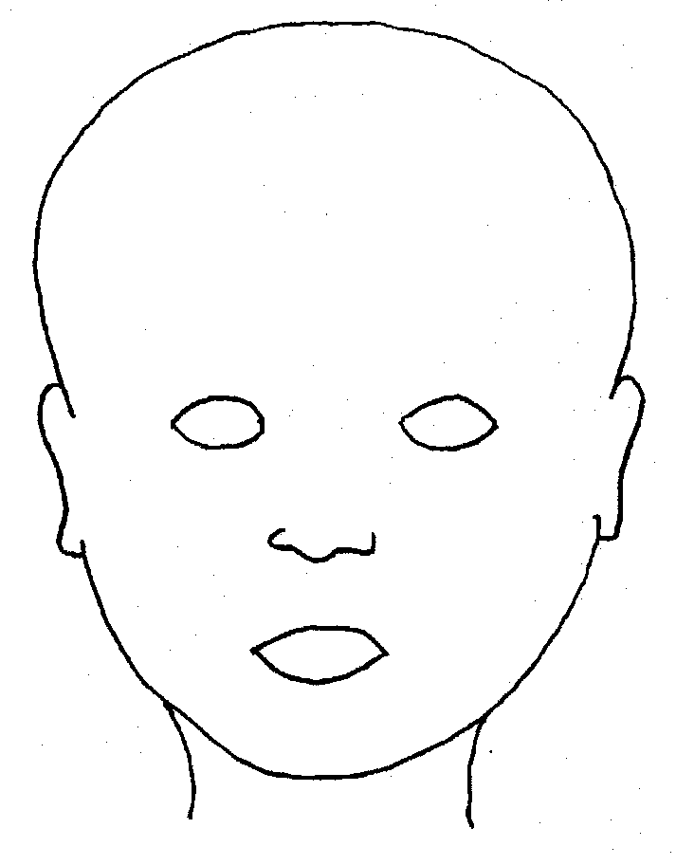
FRONT |  |  |  |  |  | BACK
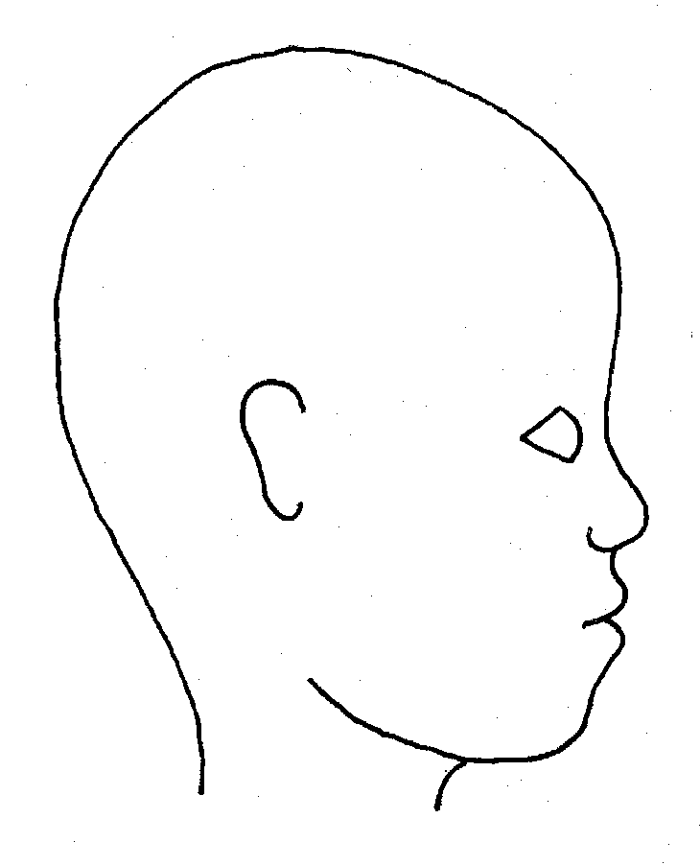 |  |  |  |  |  | 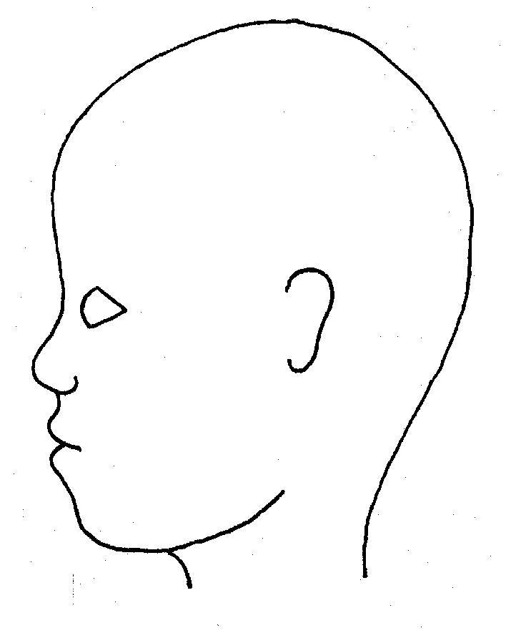
RIGHT |  |  |  |  |  | LEFT
Name of pupil: |  |  |  |  |  | Date and time of observation:
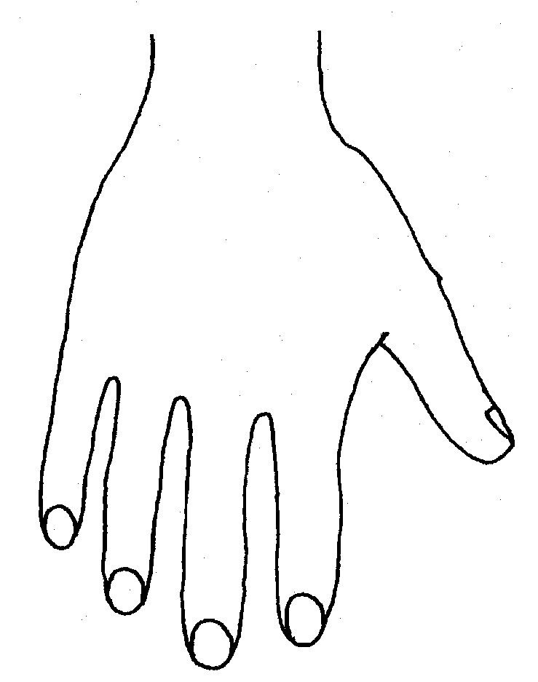 |  |  |  |  |  | 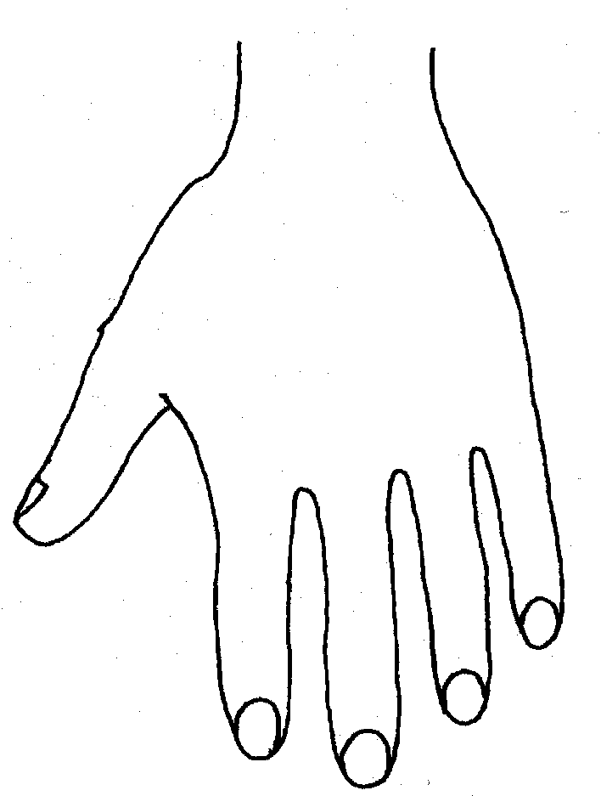
R |  |  |  |  |  | L
BACK
R |  |  |  |  |  | L
Name of Pupil: |  |  |  |  |  | Date and time of observation:
R |  | TOP |  | L | R |  | BOTTOM | L
R |  |  |  |  | L
INNER
R |  |  |  |  | L
OUTER
Printed Name, Signature and Job title of staff:
Date:

